Agent types:
Following are the different types of agents:
- Simple Reflex Agents
- Model-Based Reflex Agents
- Goal-Based Agents
- Utility-Based Agents
- Learning Agents
- Multi-Agent Systems (MAS)
- Hierarchical Agents

Simple-Reflex Agents:
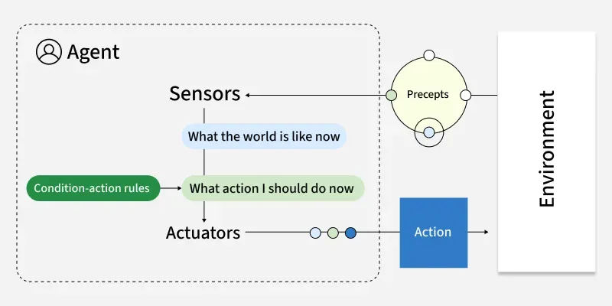

- Operate based on a set of predefined rules and respond directly to specific stimuli from the environment.
- Simple reflex agents act solely based on the current percept and predefined rules, without considering the history of past perceptions.
- These agents use condition-action rules (if-then statements) to decide on actions.
- They do not maintain any internal state or model of the environment.
- No memory of past states
- No model of how the world works
- They are the simplest form of agents and work well in environments that are fully observable and deterministic.
- Example:
A digital thermostat that adjusts the temperature based on the current room temperature.
Traffic light control systems that change signals based on fixed timing

Advantages:
- Easy to design and implement.
- Efficient in predictable environments.

Disadvantages:
- Limited functionality in complex or partially observable environments.
- Cannot learn or adapt to changes in the environment.

Model-Based Reflex Agents:
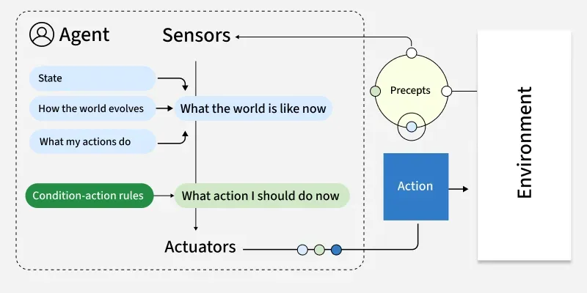

- Maintain an internal model of the world to keep track of unobservable aspects of the environment, allowing for more informed decision-making.
- They can consider the history of past perceptions to make more informed decisions.
- These agents update their internal model based on incoming percepts and use this model to infer unseen aspects of the environment.
- These agents have memory. This memory (or internal state) is built based on the history of what the agent has perceived. By storing this information, the agent can make more informed decisions because it can predict how the environment might change based on its actions.
- They use condition-action rules, but these rules can reference the internal model.
- Example:
A navigation system that uses a map to plan routes and update the user’s location.
Robot vacuum cleaners that map rooms and tracks cleaned areas

Advantages:
- Can handle partially observable environments.
- More flexible and capable than simple reflex agents.

Disadvantages:
- More complex to design and implement.
- Requires more computational resources to maintain and update the internal model.

Goal-Based Agents:
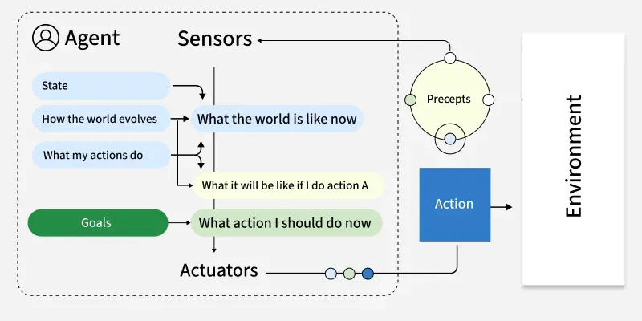

- These agents are designed to plan, execute, and adjust their actions dynamically to meet predefined goals.
- Goal-based agents operate based on predefined goals. They make decisions by evaluating how well different actions achieve these goals.
- They can plan sequences of actions to achieve their objectives.
- These agents use search and planning algorithms to determine the best course of action to reach a goal.
- They consider both the current state and the desired goal state.
- Example:
An AI planning system that schedules tasks to maximize efficiency and meet deadlines.
In autonomous vehicles, goal-based agents are used to navigate roads, avoid obstacles, and follow traffic rules.

Advantages:
- Capable of complex decision-making and planning.
- Can adapt to changes in goals and environment.

Disadvantages:
- Requires complex algorithms for search and planning.
- May be computationally intensive, especially in dynamic environments.

Utility-Based Agents:
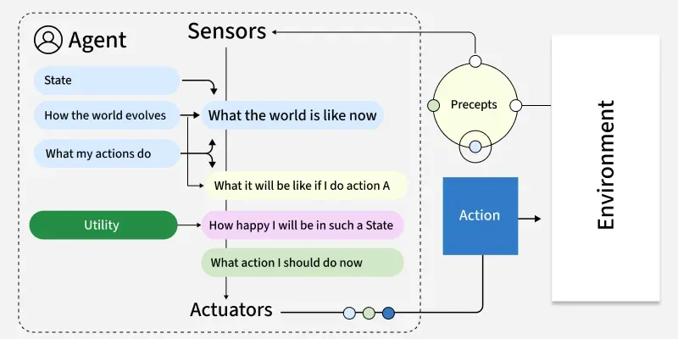

- Evaluate the utility of different actions to maximize overall satisfaction or performance.
- Utility-based agents aim to maximize their overall utility or satisfaction by evaluating the desirability of different outcomes.
- They make decisions based on a utility function that assigns a value to each possible state.
- These agents use optimization techniques to select actions that maximize their expected utility.
- They consider multiple factors and trade-offs to achieve the best overall outcome.
- Example:
An autonomous trading system that selects trades to maximize profit while minimizing risk.
Optimizing traffic in your city.
Recommending the best shows you should watch on TV.
- Use Case: Financial trading, resource management.

Advantages:
- Can handle complex decision-making scenarios involving trade-offs.
- Capable of balancing multiple objectives and preferences.
Disadvantages:
- Designing an appropriate utility function can be challenging.
- May require significant computational resources for optimization.

Learning Agents:
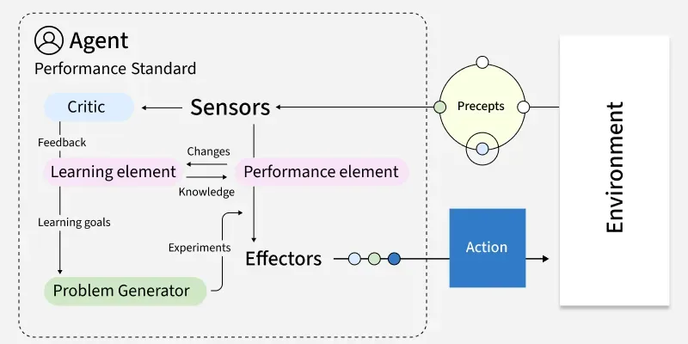

- Continuously learn from their environment and experiences to improve their performance over time, adapting to new situations and optimizing their behavior.
- They can operate in dynamic and uncertain environments by continuously updating their knowledge and strategies.
- These agents use various learning algorithms, such as supervised learning, unsupervised learning, and reinforcement learning, to acquire new knowledge and skills.
- They have four main components: a learning element, a performance element, a critic, and a problem generator.
- Example:
A recommendation engine that refines its suggestions based on user feedback and interactions.
Customer service chatbots can improve response accuracy over time by learning from previous interactions and adapting to user needs.

Advantages:
Capable of continuous improvement and adaptation.
Can handle complex and changing environments.

Disadvantages:
Requires significant amounts of data for effective learning.
The learning process can be computationally intensive and time-consuming.

Multi-Agent Systems (MAS):
- Multi-Agent Systems (MAS) consist of multiple autonomous agents that interact with each other within an environment.
- These agents may cooperate toward common goals, compete for resources or exhibit a mix of cooperative and competitive behaviors.
- Agents act independently and control their own state.
- Agents align, collaborate or compete to reach goals.
- The system remains resilient if individual agents fail.
- Decisions are distributed; there’s no single controller.
- Example, a warehouse robot might use:
Model-based reflexes for navigation
Goal-based planning for task sequencing
Utility-based decision-making for prioritizing tasks
Learning capabilities for route optimization

Hierarchical Agents:
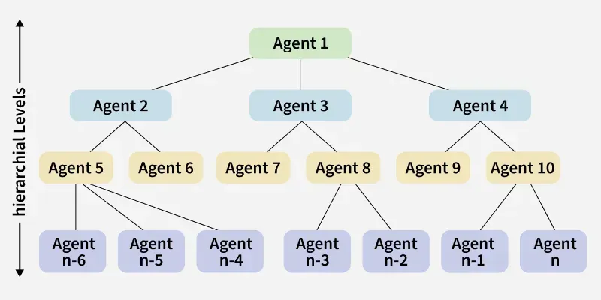

- Hierarchical agents organize decision-making across multiple levels, with high-level agents making strategic decisions and delegating specific tasks to lower-level agents.
- Division of responsibilities across multiple levels
- Abstract decision-making at higher levels
- Detailed execution at lower levels
- Simplified information flow (higher levels receive summarized data)
- Example: Drone delivery systems use drones to transport packages quickly and efficiently, utilizing GPS, sensors, and advanced flight controls to navigate and avoid obstacles

